**EXPERIMENT 2**

ER DIAGRAM FOR SAILOR BOAT DATABASE

**Aim**: Draw an ER diagram of sailors database.

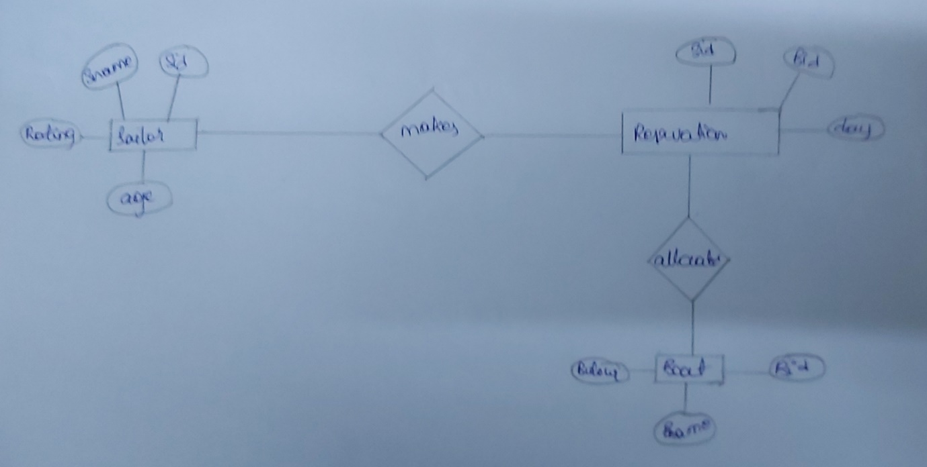

Allocated

Makes

boat

Reservations

Sailor